SerialTxDemo and SerialRxDemo

# Overview

This demonstration uses two parts. The SerialTXDemo code sends text out the serial comm port based upon the potentiometer position (measured with ADC). The SerialRxDemo code receives four characters at a time and displays them on the 2nd line of the LCD. The RS232 comm port (J14) is connected to UART 0 (RxD: P11, pin 45; TxD: P12, pin 44).

Turning the potentiometer on the transmitter board will result in the position data being sent to the receiver board and displayed there. Communication is at 38400 baud, 8 data bits, no parity.

Connect the RDKs as shown in the figures below.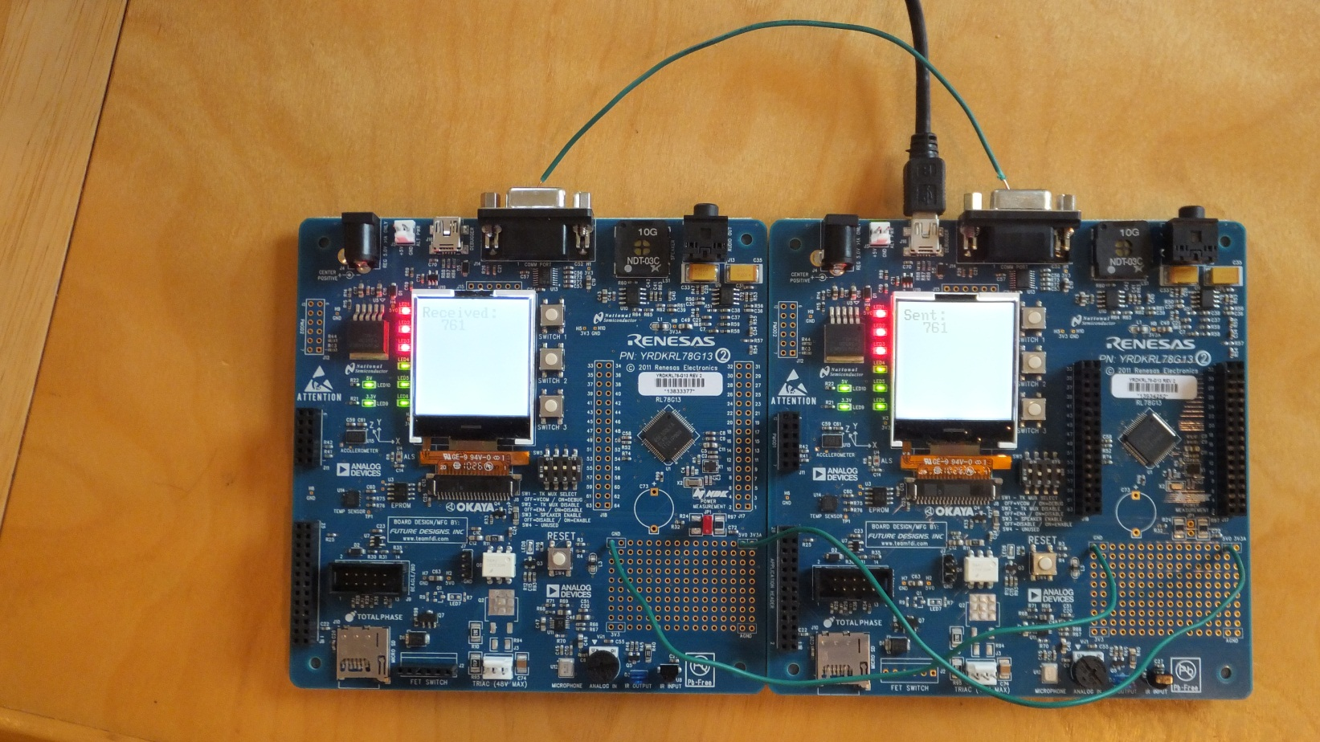

Figure . Overview of two RDKs. Right board is transmitter, left board is receiver. Right board is powered from USB cable, left board is powered through wires connected to GND and 5V0 pads in prototyping area.

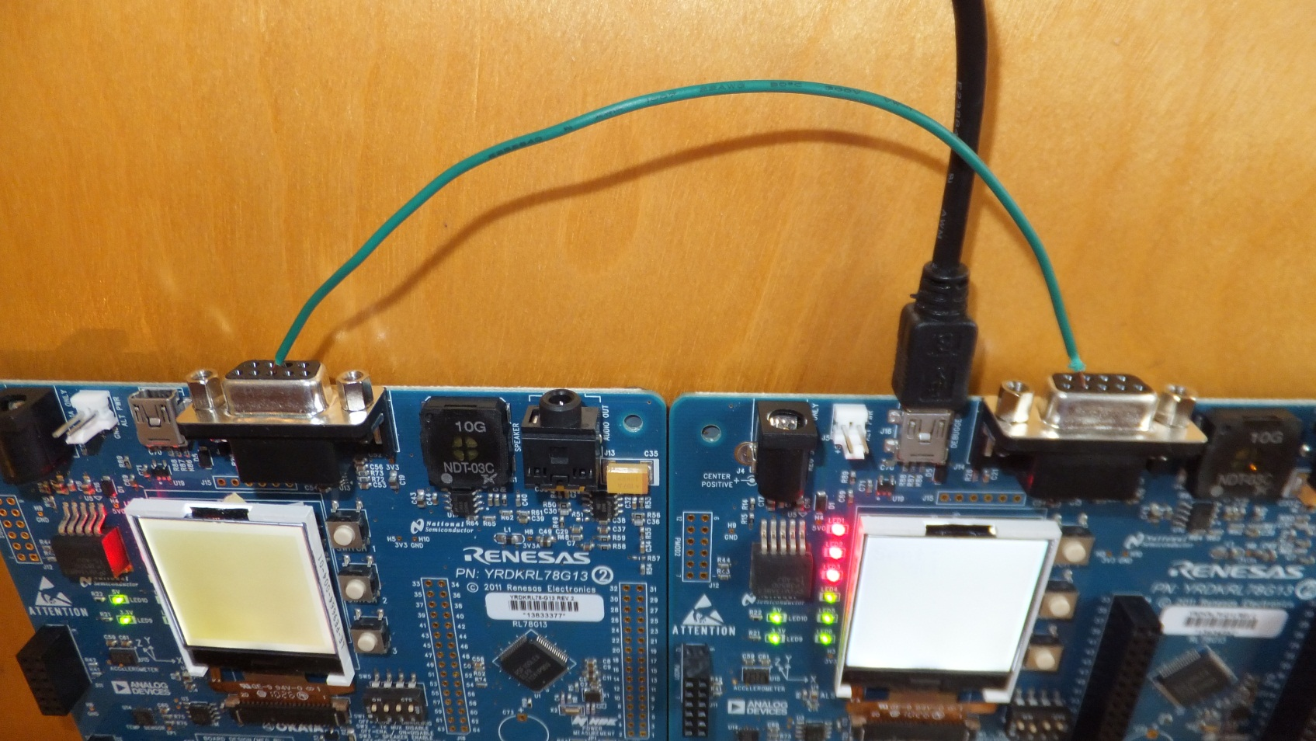

Figure 2. Detail from back showing J14 RS232 transmit data signal (pin 2 on right board (transmitter) connected to Rx Data signal pin 3 on left board (receiver).

# Comments and Suggestions

* Program one RDK at a time.